ERASMUS+
KA2 - COOPERATION FOR INNOVATION AND THE EXCHANGE OF GOOD PRACTICES
STRATEGIC PARTNERSHIPS FOR VOCATIONAL EDUCATION AND TRAINING

KEEP LAB SAFETY
KEEP YOU HEALTHY

2017-1-TR01-KA202-046148

NEEDS ANALYSIS REPORT

June 2018
Funded by the Erasmus+ Program of the European Union. However, European Commission and Turkish National Agency cannot be held responsible for any use which may be made of the information contained therein.
Funded by the Erasmus+ Program of the European Union. However, European Commission and Turkish National Agency cannot be held responsible for any use which may be made of the information contained therein.

KEEP LAB SAFETY KEEP YOU HEALTHY
(2017-1-TR01-KA202-046148)
NEEDS ANALYSIS REPORT
INTRODUCTION
Our project code 'KEEP LAB SAFETY KEEP YOU HEALTHY' was launched on 1st October.2017 with the code 2017-1-TR01-KA202-046148. This project is aimed at creating awareness about biosecurity in non-physician health personnel working with the main purpose clinical samples; to be developed through face-to-face interactive standardized training programs, and to disseminate correct and up-to-date information on biosafety issues through the web environment. Our ultimate goal for this purpose is to prevent work accidents in laboratories working with clinical specimens. It is extremely important to determine the needs of the target group so that the trainings to be given and the materials to be prepared are effective. For this purpose, questionnaires, face-to-face interviews, focus group interviews and observations were conducted. Basically, the data gathered by the questionnaire method were evaluated in this report.

METHOD
Preliminary Process
In order to form a needs analysis questionnaire, a project team was gathered and questions were created. The questionnaire, which was applied to a small group of 5 people, was re-examined and tthen he survey was finalized. Care has been taken to keep the questionnaire as short as possible in the direction of the suggestions received.

Target group
It was estimated that a target mass of 150 people would be sufficient for the evaluation. Within this scope, a total of 150 laboratory workers working in Akdeniz University, Ankara University, Hitit University and Kırıkkale University were included in the questionnaire.

Survey
The questionnaire consists of two main parts (Annex 1):
With the 8 questions in the first part, it is aimed to collect epidemiological data including demographic data as well as laboratory study periods.
In the second part, 15 multiple choice questions were applied.
The questionnaire is applied on a web-based basis through the http://www.surveey.com/survey/ site which is accessible online. Staff with poor computer skills helped to get into the system.

Time
For the implementation of the survey, the system is open between 05/03/ 2018-10 / 06/ 2018. After reaching the targeted number of 150, the system was shut down.

RESULTS
Demographic Data
The data of 150 participants in the survey are summarized below:
- 66% of the participants were female, 34% were male (Figure 1).
- 12% have high school, 20% have pre-license, 39% have graduate, 10% have master's degree and 19% have doctorate diploma (Figure 2).
- 17% of university degree holders from biology department, 13% from pharmacy faculty, 3% from molecular biology and genetics department, 2% from bioengineering department and 1% were from nursing faculty.
- 9% from health vocational high school, 7% from health vocational high school and 47% were from other departments (Figure 3).
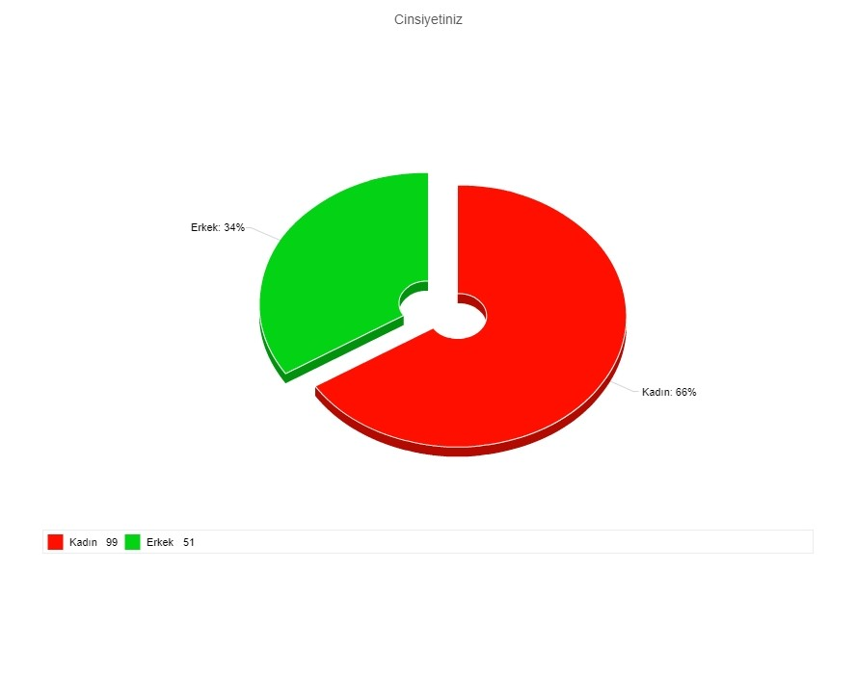
- 28% are in Kırıkkale University, 17% are in Hitit University, 15% are in Ankara University, 8% are in Akdeniz University and 32% are in other institutions.

Figure 1: Gender distribution

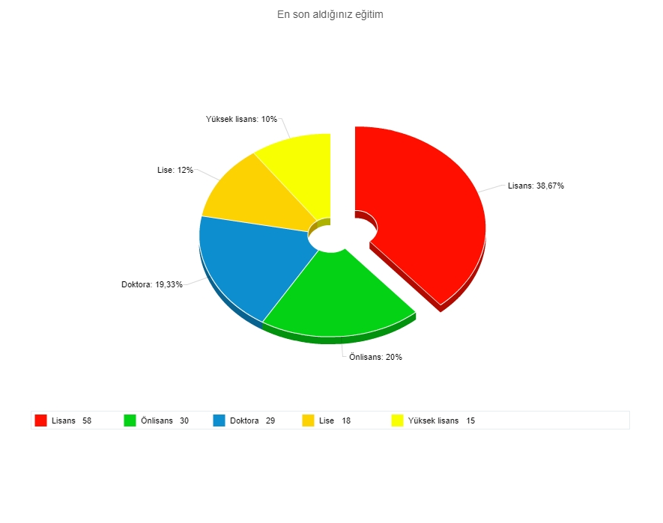

Figure 2: Educational situation
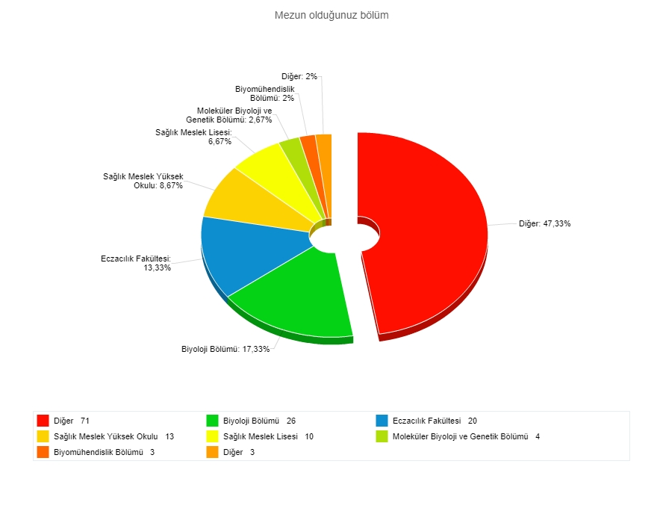
Figure 3: Graduated section
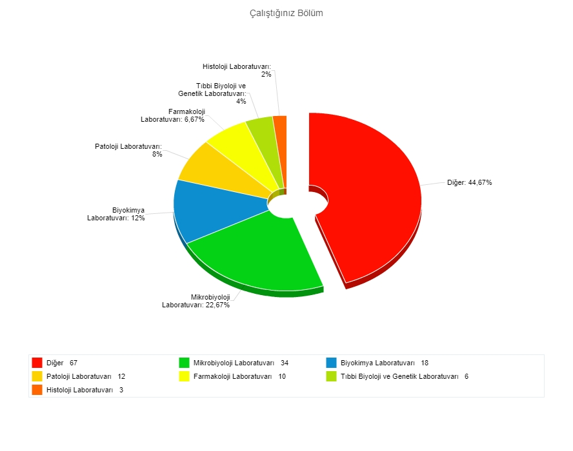
Figure 4: Job description

• 23% of the respondents work in microbiology, 12% in biochemistry, 8% in pathology, 7% in pharmacology, 4% in medical biology and genetics, 2% in histology laboratories; While 45% are in combined laboratories (Figure 4).
• 44% have worked in the laboratory since the year 0-5 years, 16% 6-10 years, 10% 11-15 years, 7% 16-20 years and the rest 21 years and over.

Questions about Laboratory Safety
- Cooler Usage:
15% of respondents answered incorrectly the question about using the + 4 ° C cooler (Figure 5).
2. Fume Hood Usage:
Those who think that the working principle of the burner stoves is the same as the biosafety cabinets; 36% are doctoral, 9% are graduate, 28% are undergraduate, 17% are pre-graduate and 7% are high school graduates. 9% of the wrong responders work in biochemistry, 5% in pharmacology, 17% in microbiology, 7% in pathology, 3% in medical biology and genetics and 55% in other laboratories. 35% of those who do not know that they will not work with biological material in the fume hoods are microbiology laboratories. 33% of stuff working in the biochemistry laboratory, 30% working in the pharmacology laboratory, 33% working in the histology laboratory, 23% working in the microbiology laboratory and 16% working in the pathology laboratory do not know that the fume hoods only protects against chemical vapor toxicity (Figure. 6).
3. Biosafety Rules:
63% of the respondents answered the question incorrectly. Of these, 38% do not know that infectious waste needs to be autoclaved, 16% do not know that pipetting should not be done by mouth (Figure. 7).
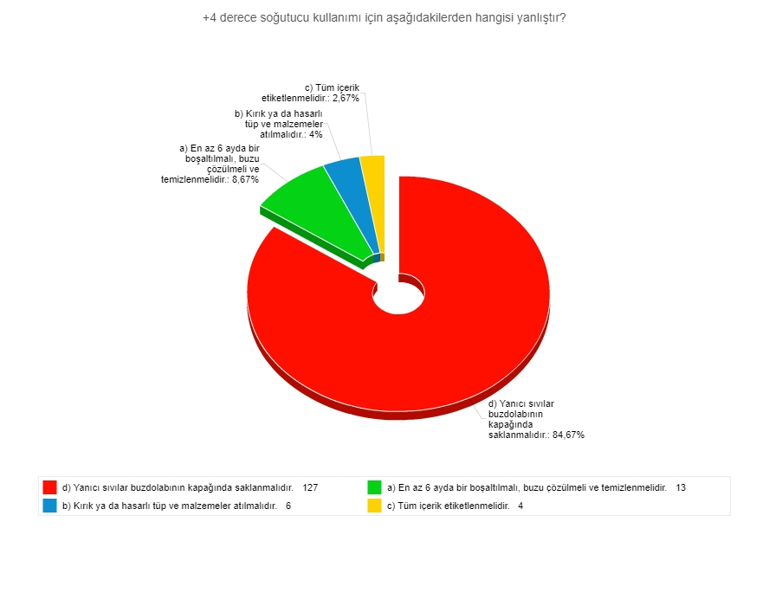
Figure 5: Cooler usage
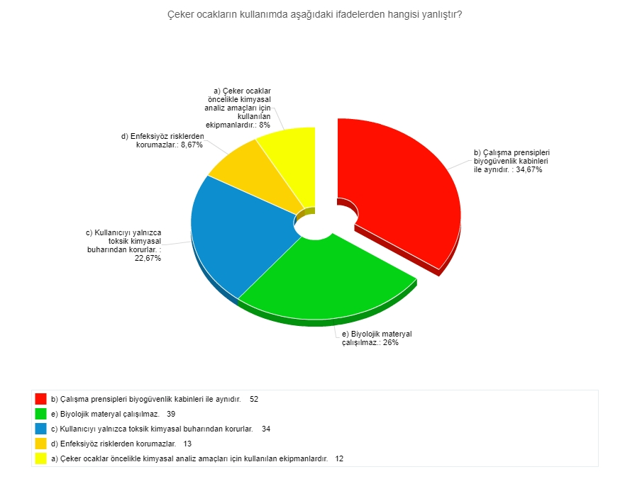
Figure 6: Fume Hood usage
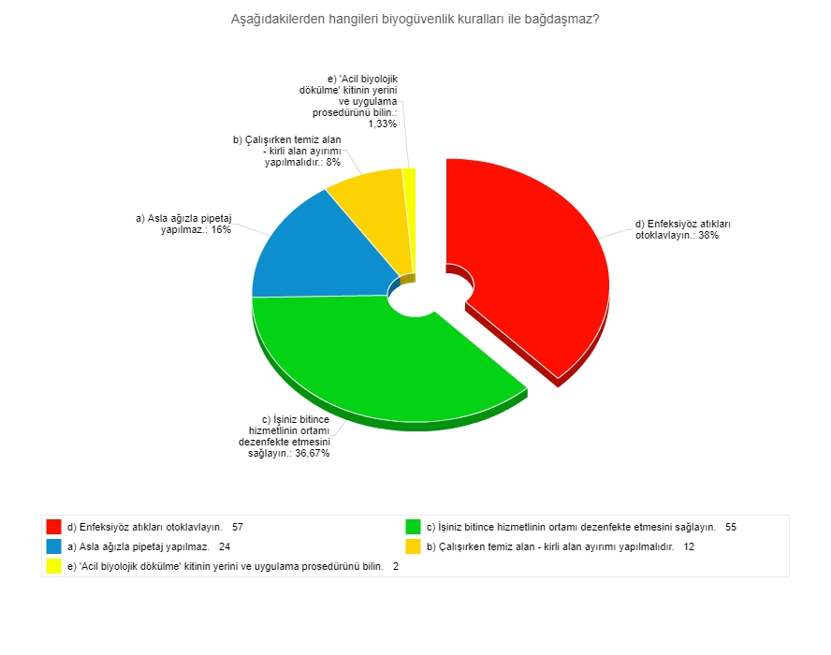

Figure 7: Biosafety rules
4. Chemical Spill and Scatter:
26% of the respondents do not know what to do when any chemical is poured into the working environment. 13% had misinformation about penetrating injuries and 2% were unaware that penetrating injuries were significant due to the possibility of catching HIV, Hepatitis B and C infections, which can be fatal (Figure 8).
5. Penetrating injuries
13% of respondents do not have the correct knowledge about the importance of wearing gloves against penetrating injuries (Figure 9).

6. Laboratory Safety Risk Groups:
12% of the respondents do not know the risk groups in terms of laboratory safety; 6.6% of these risky groups are those carrying biological and hazardous wastes (Figure 10).
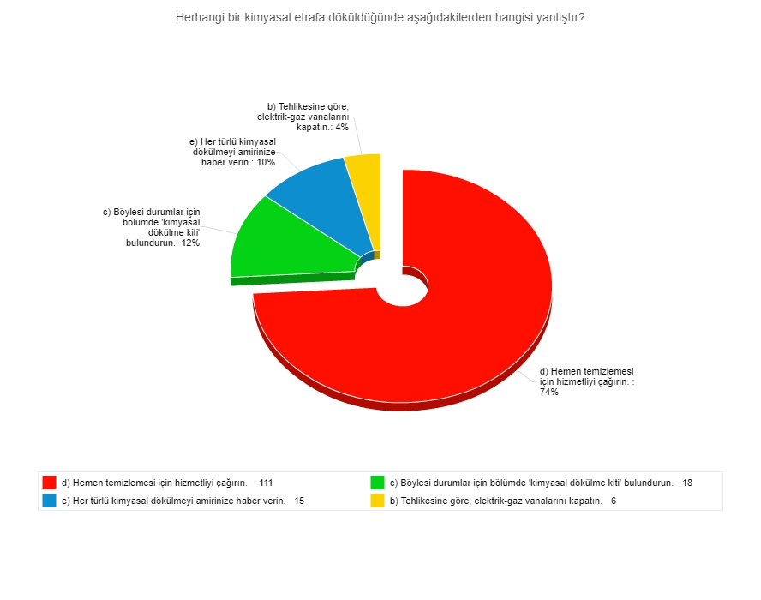
Figure 8: Chemical spill / scatter

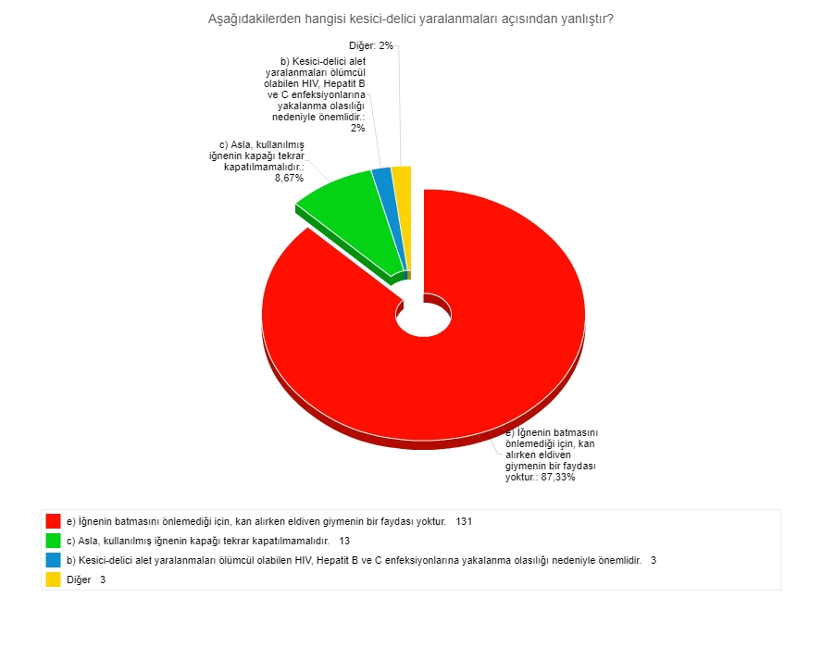

Figure 9: Penetrating injuries

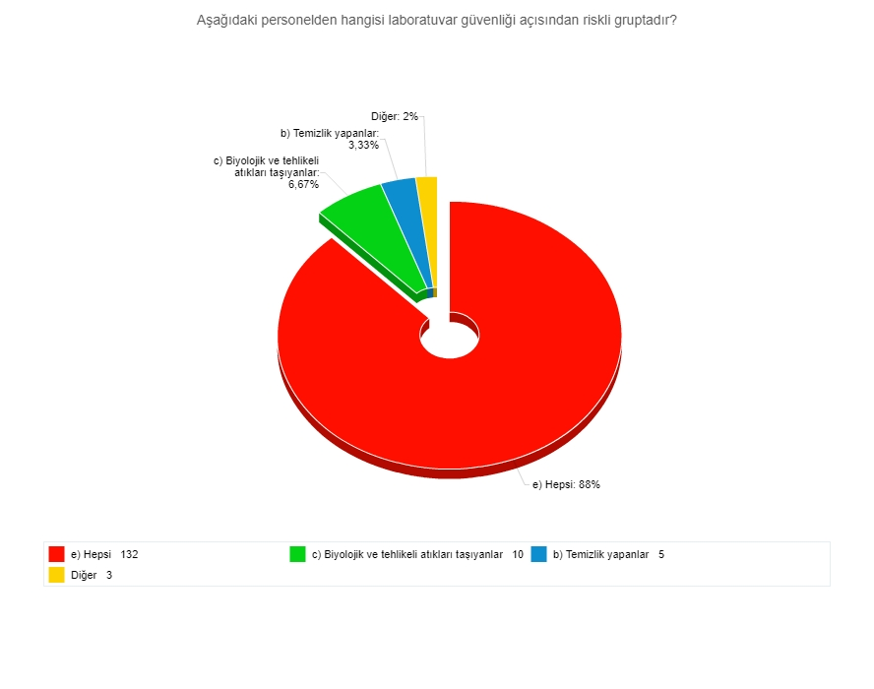
Figure 10: Laboratory safety risk groups

7. Handling Gloves:
Only 4% of respondents gave the wrong answer about glove use, and 1.3% of them do not know that gloves should be used when handling biological wastes (Figure 11).

8. General Rules
18% of the respondents do not know the general rules for the provision of laboratory safety. 9% do not know that the badge should be worn, 3% do not know that they should not eat and drink in the laboratory (Figure 12).
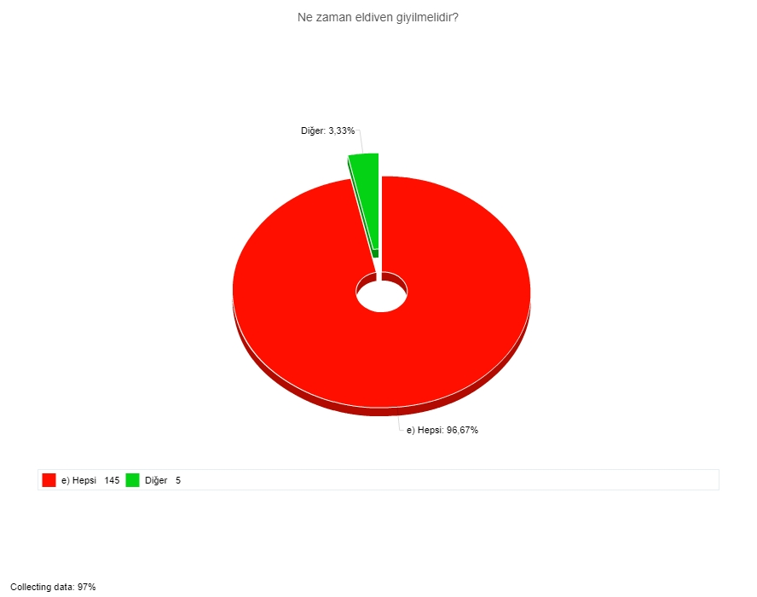

Figure 11: Glove Usage
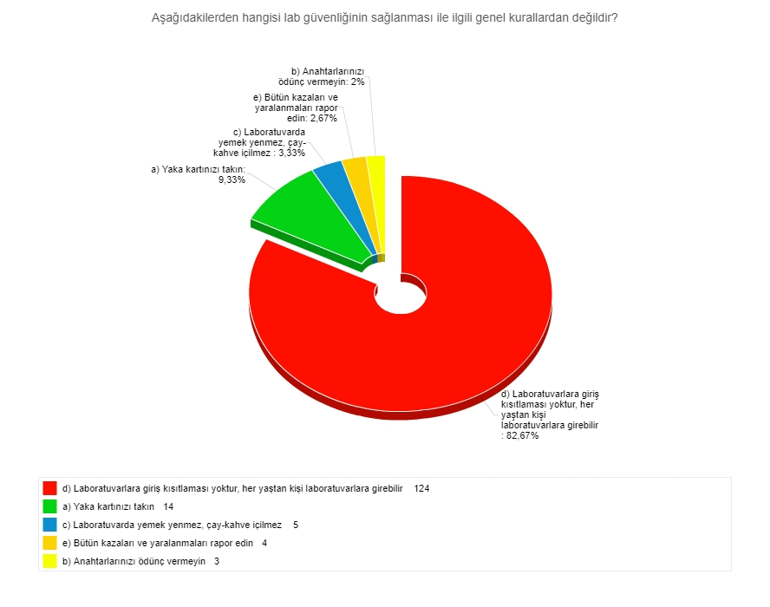

Figure 12: General Rules

- Person in charge
44% of respondents do not know who is responsible for laboratory safety, and 22.66% of them think that only laboratory staff are responsible (Figure 13).
- Use of Laboratory Coat
28% of the respondents do not know that laboratory wear should only be worn while working in the laboratory, 16% of them think that there is no restriction on lab coat clothing, and 9% think that lab coat can be worn in laboratory and office sections. 3% think that it is a suitable work wear that can be worn throughout the day in terms of the protection of personal items such as wallet, mobile phone (Figure 14).

11. Infectious Material Spillage
17% of respondents do not know what to do when any infectious material is spilled (Figure 15).

- Waste Bags
28% of the respondents know the bags they need to put in waste.14% of them do not know that animal wastes and 3.3% do not know that medical wastes should be placed in red bags (Figure 16).

13. Fire Extinguisher
5% of respondents misunderstood that water should be used for the type of fire (Figure 17).
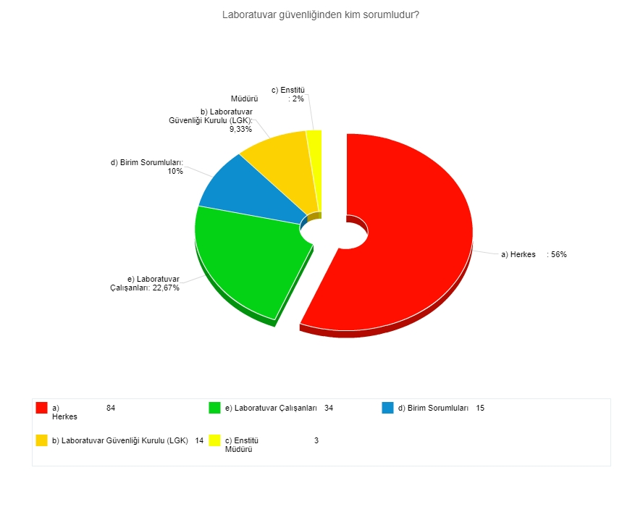

Figure 13: Person in charge

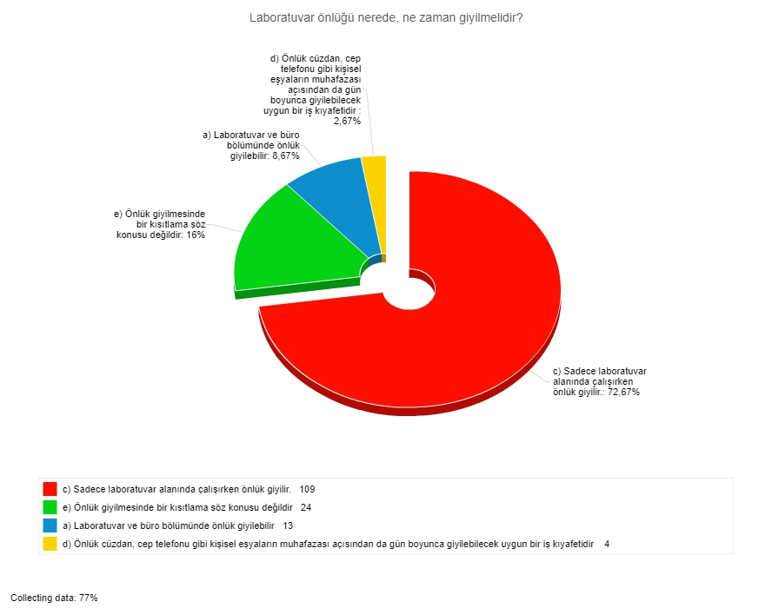

Figure 14: Use of the laboratory coat

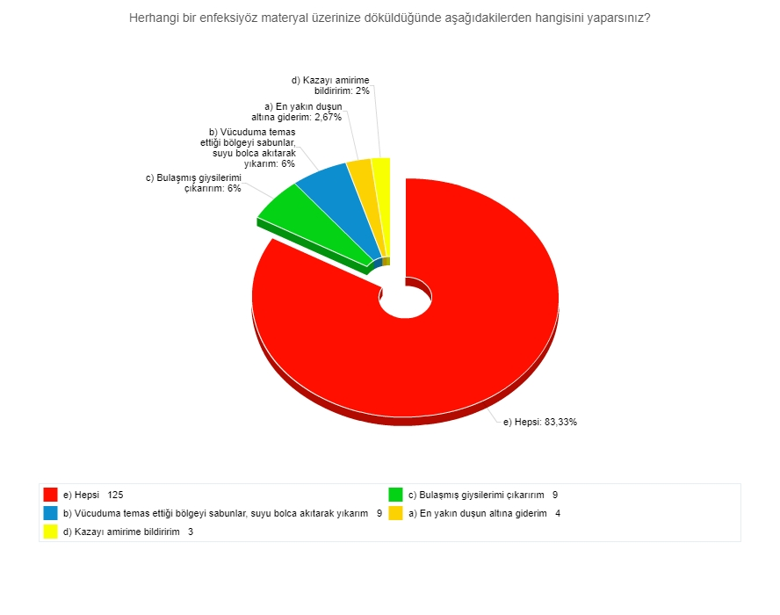
Figure 15. Infectious material spillage
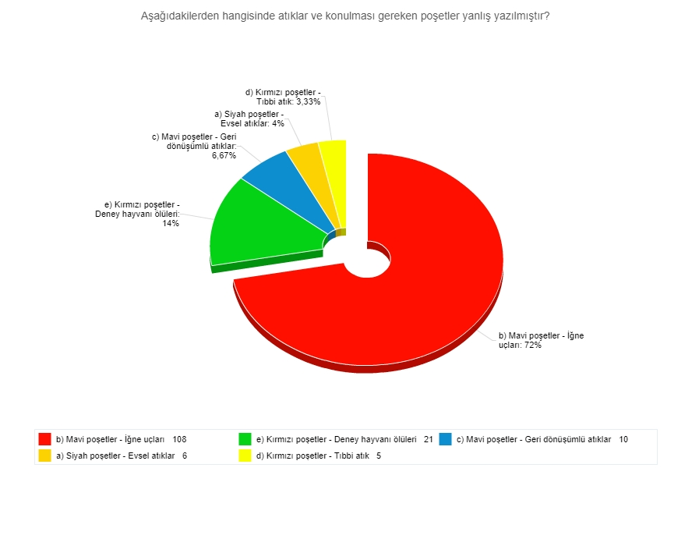

Figure 16. Waste bags
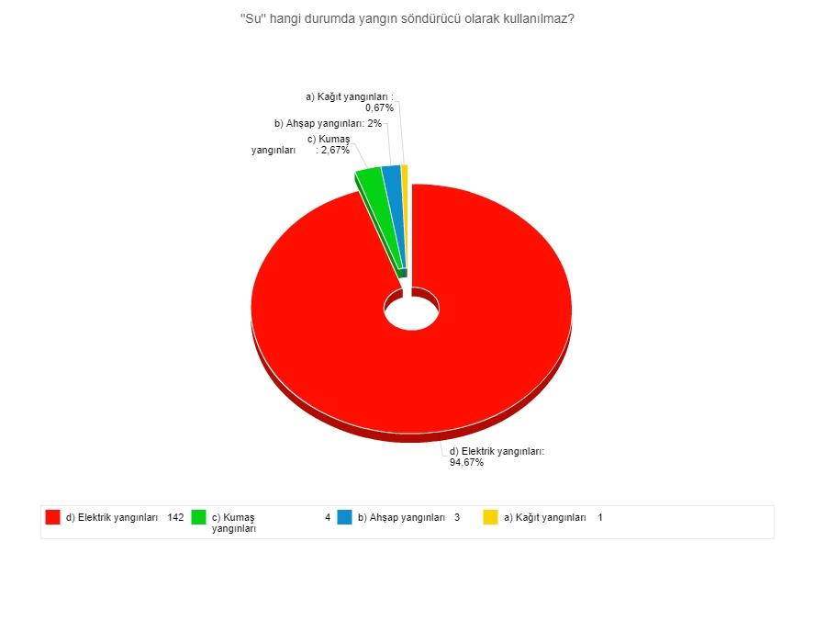

Figure 17. Fire extinguishers

14. BSL (BioSafety Level) 2
68% of those surveyed misunderstand what the minimum biosafety level of laboratories working with human specimens should be. Furthermore, only 18% of them know biosafety level 1, 24% biosafety level 3, 9.3% biosafety level 4 and 16.6% biosafety level 5 (Figure 18).
15. Autoclave Tape
83% of respondents do not know the purpose of autoclave tape. Of these, 41.3% knew that they were used to control sterilization but did not know that it was a biological indicator and thought it was used as a chemical indicator. In addition, 18% of the participants thought that autoclave tape was used to control whether the autoclave was in operation, 18% was used to prevent the materials in the autoclave from being poured during sterilization, and 5.3% was used to prevent steam from the autoclave.
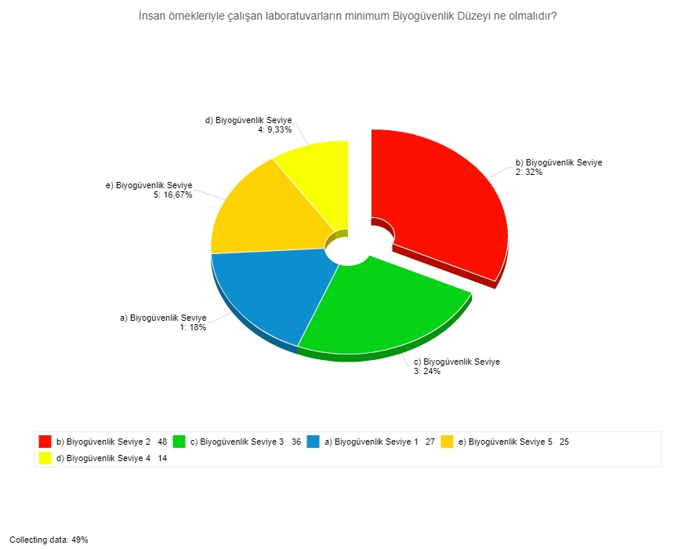

Figure 18. BSL levels
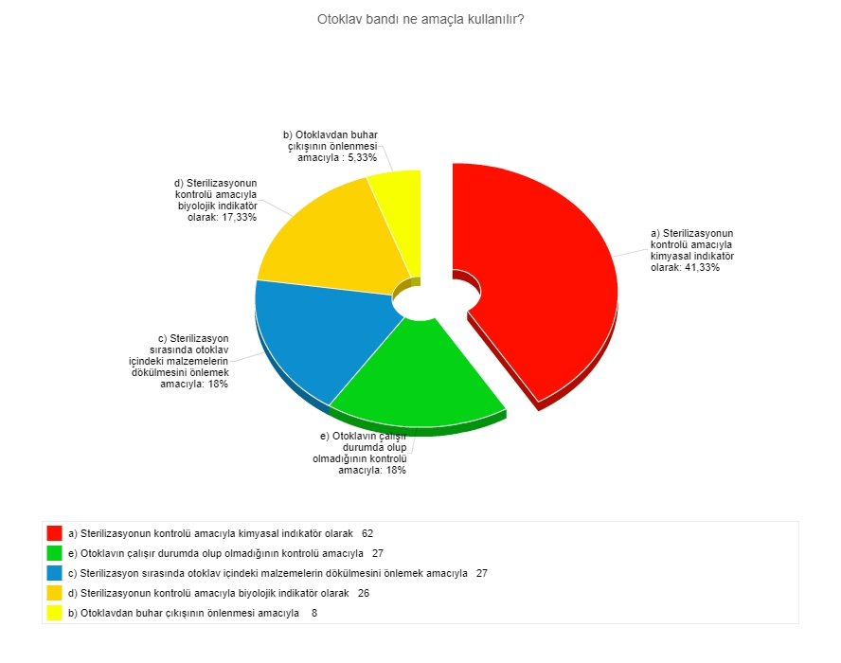

Figure 19. Autoclave tape

CONCLUSION
Even this simple questionnaire emphasizes the low level of awareness of laboratory safety, especially biological risks, especially in non-physicians. The observed situations and interviews have determined how low this awareness is, regardless of level of education and profession. It is thought that the web based innovative education techniques for young people are more beneficial to the classical education techniques for the aged personnel. The projecting of experience from international partners, the creation of training curricula and the development of training techniques will be effective in successfully solving this deficiency in laboratory staff.

